JAVA PROJECT – CAR RENTAL FLEET MANAGER

Programming for Problem Solving – Java
Presented by: Gundu Meghana | Roll No: 2620030053
SLIDE 1: TITLE SLIDE
Car Rental Fleet Manager
Programming for Problem Solving – Java
Presented by: Gundu Meghana | 2620030053
SLIDE 2: ABSTRACT
A Java-based console application for managing rental vehicles, customers, and transactions end-to-end.
Core Operations
View, search, rent, and return cars with real-time availability tracking
Customer & Records
Manage customer information and maintain persistent rental records
Analytics & Reports
Sorting, filtering, receipt generation, and fleet statistics
Java Progression
Demonstrates Modules 1–6 of the Java PSP syllabus in one cohesive project
SLIDE 3: PROJECT OBJECTIVES & KEY FEATURES
Project Objectives & Key Features
Fleet Management
Manage car info and track real-time availability across the fleet
Search & Filter
Quickly search and filter vehicles by brand, price, or availability
Transactions
Handle rental and return processing with automated cost calculation
Customer Records
Maintain customer details and complete rental histories
Fleet Statistics
Generate reports: available/rented count and total revenue summary
File Persistence
File-based record storage for data durability across sessions
Advantages
- Reduces manual work and paperwork
- Improves organization and data management
- Enables quick searching and filtering
- Automates cost calculation and billing
- Demonstrates modular and scalable design
- Supports efficient fleet analysis and reporting
SLIDE 4: JAVA CONCEPTS USED:
Module 1: Variables, Data Types & I/O
Variables, data types, operators, Scanner, console I/O, algorithm design
Module 2: Control Flow
if-else, switch, loops (for, while, do-while), break, continue
Module 3: Methods & Arrays
Methods, arrays, searching, sorting, recursion, method overloading
Module 4: Object-Oriented Programming
Classes, objects, constructors, encapsulation, inheritance, interfaces, polymorphism, exception handling
Module 5: Strings & File I/O
Strings, file I/O, BufferedReader/Writer, Collections.sort(), Comparable, Comparator
Module 6: Collections & Streams
ArrayList, HashMap, HashSet, generics, lambda expressions, streams, Collectors
SLIDE 5: SYSTEM ARCHITECTURE & CLASS DESIGN
System Architecture
User Input: Main menu-driven interface
Core Modules: Car management, customer management, rental processing, search/sort, file operations, reports
Data Flow: Input → Processing → Storage → Output
Output: Receipts, statistics, fleet information
Class Design
Car Class
- carId, carName, category, pricePerDay, available (boolean)
- Methods: getters, setters, calculateRentalCost()
Customer Class
- customerId, customerName, phoneNumber, email
- Methods: getters, toString()
Rental Class
- rentalId, car, customer, startDate, days, totalCost
- Methods: getTotalCost(), toString()
CarRentalManager Class
- Manages lists of cars, customers, rentals
- Handles all operations and menu-driven interface
SLIDE 6: IMPLEMENTATION DETAILS – MODULES 1 TO 6
Module 1: I/O & Variables
Input handling, variables, operators, Scanner, algorithm design
Module 2: Control Flow
Conditional logic, switch statements, loop-based iterations
Module 3: Methods & Arrays
Methods for operations, arrays for storage, searching/sorting algorithms
Module 4: OOP Principles
OOP principles, constructors, encapsulation, inheritance, exception handling
Module 5: Strings & File I/O
String operations, file I/O for persistence, sorting with Comparable/Comparator
Module 6: Collections & Streams
Collections (ArrayList, HashMap), generics, lambda expressions, stream processing
SLIDE 7: COMPLETE JAVA CODE IMPLEMENTATION

Key Features:
- Car, Customer, Rental classes with full encapsulation
- Menu-driven interface with 12 operations
- Rental processing with validation
- Stream-based filtering and sorting
- File persistence (save/load)
- Exception handling
- All 6 modules demonstrated
SLIDE 8: RENTAL PROCESS WORKFLOW & SAMPLE OUTPUT
Rental Process Workflow
- Select Car - Display available cars (Module 1, 2)
- Check Availability - Verify car status (Module 2, 4)
- Customer Details - Input and validate (Module 1, 4)
- Rental Duration - Enter days (Module 1)
- Calculate Cost - Apply formula (Module 3, 5)
Fleet Statistics Output
--- Fleet Statistics ---
Total Cars: 5
Available: 4
Currently Rented: 1
Total Revenue: ₹7500
========================
SLIDE 9: OUTPUT SCREENSHOT 2
[Screenshot of program output showing menu and car fleet data]
SLIDE 10: SAMPLE FLEET DATA
101 Swift Hatchback ₹1500.0 ✅
102 Baleno Hatchback ₹1700.0 ✅
103 Creta SUV ₹2500.0 ✅
104 City Sedan ₹2200.0 ❌
105 Nexon SUV ₹1800.0 ✅
Fleet managed using ArrayList and HashMap (Module 6) — sorted by price via Comparator (Module 5) and filtered using Streams (Module 6).
SLIDE 11: CONCLUSION & FUTURE WORK
Conclusion
- Successfully demonstrates all six Java PSP modules in one cohesive project
- Progresses from basic I/O and control flow to advanced OOP and functional programming
- Integrates file handling, collections, and stream processing practically
- This project deepened my understanding of Java fundamentals and OOP principles while helping me grow more confident in building structured, maintainable applications
- It also strengthened my problem-solving and system design skills, improved my code organization and best practices, and gave me hands-on experience connecting multiple concepts into one cohesive solution
Future Work
- GUI (Swing/JavaFX) - Transform the console-based application into an intuitive, modern GUI using Swing or JavaFX, enabling seamless user interaction, streamlined workflows, and a more polished professional experience
- Database Integration - Migrate from file-based storage to a robust relational database such as MySQL or PostgreSQL, ensuring reliable data persistence, concurrent access, and enterprise-grade scalability
- Web & REST APIs - Develop a full-featured web application with RESTful APIs to support cloud-based access, real-time synchronization, and seamless integration with third-party services and platforms
- Mobile Application - Create native Android and iOS applications to extend the platform's reach, empowering customers to book, track, and manage rentals on the go with push notifications and mobile-first convenience
- Advanced Features & Analytics - Implement payment gateway integration, customer review systems, loyalty programs, and an AI-driven analytics dashboard to support smarter, data-informed decision making
- Cloud Deployment & DevOps - Deploy on AWS or Azure with Docker containerization, CI/CD pipelines, real-time tracking, and automated scaling to deliver global accessibility, resilience, and high availability
SLIDE 12: THANK YOU
Thank You
This Car Rental Fleet Manager project provided a comprehensive hands-on experience in applying core Java principles to a practical, real-world scenario. It effectively demonstrated object-oriented programming, data structures (like ArrayList and HashMap), file handling, and fundamental algorithms, all integrated into a functional application. We hope this presentation showcased the foundational knowledge and problem-solving skills acquired through this project.
"Programming is not about writing code - it's about solving problems systematically."
View Project on GitHub: https://github.com/gundumeghana/CarRentalFleetManager
Presented by: Gundu Meghana
You can now copy this content and paste it into your Word document! Would you like me to format it differently or add any additional information?
Pls convert the entire ppt to wor
CAR RENTAL FLEET MANAGER
Programming for Problem Solving – Java
Presented by: Gundu Meghana | Roll No: 2620030053
SLIDE 1: CAR RENTAL FLEET MANAGER
Car Rental Fleet Manager
Programming for Problem Solving – Java
Presented by: Gundu Meghana | 2620030053
SLIDE 2: ABSTRACT
A Java-based console application for managing rental vehicles, customers, and transactions end-to-end.
Core Operations
View, search, rent, and return cars with real-time availability tracking
Customer & Records
Manage customer information and maintain persistent rental records
Analytics & Reports
Sorting, filtering, receipt generation, and fleet statistics
Java Progression
Demonstrates Modules 1–6 of the Java PSP syllabus in one cohesive project
SLIDE 3: PROJECT OBJECTIVES & KEY FEATURES
Project Objectives & Key Features
Fleet Management
Manage car info and track real-time availability across the fleet
Search & Filter
Quickly search and filter vehicles by brand, price, or availability
Transactions
Handle rental and return processing with automated cost calculation
Customer Records
Maintain customer details and complete rental histories
Fleet Statistics
Generate reports: available/rented count and total revenue summary
File Persistence
File-based record storage for data durability across sessions
Advantages
- Reduces manual work and paperwork
- Improves organization and data management
- Enables quick searching and filtering
- Automates cost calculation and billing
- Demonstrates modular and scalable design
- Supports efficient fleet analysis and reporting
SLIDE 4: JAVA PSP MODULES USED
Java PSP Modules Used
Module 1: Variables, Data Types & I/O
Variables, data types, operators, Scanner, console I/O, algorithm design
Module 2: Control Flow
if-else, switch, loops (for, while, do-while), break, continue
Module 3: Methods & Arrays
Methods, arrays, searching, sorting, recursion, method overloading
Module 4: Object-Oriented Programming
Classes, objects, constructors, encapsulation, inheritance, interfaces, polymorphism, exception handling
Module 5: Strings & File I/O
Strings, file I/O, BufferedReader/Writer, Collections.sort(), Comparable, Comparator
Module 6: Collections & Streams
ArrayList, HashMap, HashSet, generics, lambda expressions, streams, Collectors
SLIDE 5: SYSTEM ARCHITECTURE & CLASS DESIGN
System Architecture
User Input: Main menu-driven interface
Core Modules: Car management, customer management, rental processing, search/sort, file operations, reports
Data Flow: Input → Processing → Storage → Output
Output: Receipts, statistics, fleet information
Class Design
Car Class
- carId, carName, category, pricePerDay, available (boolean)
- Methods: getters, setters, calculateRentalCost()
Customer Class
- customerId, customerName, phoneNumber, email
- Methods: getters, toString()
Rental Class
- rentalId, car, customer, startDate, days, totalCost
- Methods: getTotalCost(), toString()
CarRentalManager Class
- Manages lists of cars, customers, rentals
- Handles all operations and menu-driven interface
SLIDE 6: IMPLEMENTATION DETAILS – MODULES 1 TO 6
Implementation Details – Modules 1 to 6
M1 – I/O & Variables
Input handling, variables, operators, Scanner, algorithm design
M2 – Control Flow
Conditional logic, switch statements, loop-based iterations
M3 – Methods & Arrays
Methods for operations, arrays for storage, searching/sorting algorithms
M4 – OOP Principles
OOP principles, constructors, encapsulation, inheritance, exception handling
M5 – Strings & File I/O
String operations, file I/O for persistence, sorting with Comparable/Comparator
M6 – Collections & Streams
Collections (ArrayList, HashMap), generics, lambda expressions, stream processing
SLIDE 7: COMPLETE JAVA CODE IMPLEMENTATION
Complete Java Code Implementation
import java.io.*;
import java.nio.file.*;
import java.util.*;
import java.util.stream.Collectors;

public class CarRentalFleetManager {

// MODULE 4: CLASS, OBJECT, ENCAPSULATION
static class Car {
private int carId;
private String carName;
private String category;
private double pricePerDay;
private boolean available;

public Car(int carId, String carName, String category, double pricePerDay, boolean available) {
this.carId = carId;
this.carName = carName;
this.category = category;
this.pricePerDay = pricePerDay;
this.available = available;
}

public int getCarId() { return carId; }
public String getCarName() { return carName; }
public String getCategory() { return category; }
public double getPricePerDay() { return pricePerDay; }
public boolean isAvailable() { return available; }
public void setAvailable(boolean available) { this.available = available; }

@Override
public String toString() {
return "ID: " + carId + " | Name: " + carName + " | Category: " + category +
" | Price/Day: ₹" + pricePerDay + " | Available: " + available;
}
}

// MODULE 6: COLLECTIONS - ArrayList, HashMap
static ArrayList<Car> fleet = new ArrayList<>();
static HashMap<String, Integer> rentals = new HashMap<>();

// MODULE 1 & 3: METHODS
public static void displayCars() {
System.out.println("\n========== CAR FLEET ==========");
for (Car car : fleet) {
System.out.println(car);
}
}

public static Car searchCar(int carId) {
for (Car car : fleet) {
if (car.getCarId() == carId) {
return car;
}
}
return null;
}

// MODULE 2: CONDITIONAL STATEMENTS
public static void rentCar(Scanner sc) {
System.out.print("Enter Car ID: ");
int id = sc.nextInt();
sc.nextLine();

Car car = searchCar(id);

if (car == null) {
System.out.println("Car not found.");
} else if (!car.isAvailable()) {
System.out.println("Car is already rented.");
} else {
System.out.print("Enter customer name: ");
String customer = sc.nextLine();
car.setAvailable(false);
rentals.put(customer, id);
System.out.println("Car rented successfully!");
}
}

// MODULE 1: ARITHMETIC OPERATORS
public static void calculateRentalCost(Scanner sc) {
System.out.print("Enter Car ID: ");
int id = sc.nextInt();
Car car = searchCar(id);

if (car == null) {
System.out.println("Car not found.");
return;
}

System.out.print("Enter number of rental days: ");
int days = sc.nextInt();

if (days <= 0) {
System.out.println("Invalid number of days.");
return;
}

double total = car.getPricePerDay() * days;
double discount = (days >= 7) ? total * 0.10 : 0;
double finalAmount = total - discount;

System.out.println("\n========== BILL ==========");
System.out.println("Car: " + car.getCarName());
System.out.println("Price per day: ₹" + car.getPricePerDay());
System.out.println("Days: " + days);
System.out.println("Total: ₹" + total);
System.out.println("Discount: ₹" + discount);
System.out.println("Final Amount: ₹" + finalAmount);
}

// MODULE 5: STRING OPERATIONS
public static void searchByName(Scanner sc) {
System.out.print("Enter car name: ");
String name = sc.nextLine();
boolean found = false;

for (Car car : fleet) {
if (car.getCarName().equalsIgnoreCase(name)) {
System.out.println(car);
found = true;
}
}

if (!found) {
System.out.println("Car not found.");
}
}

// MODULE 6: STREAMS & LAMBDA EXPRESSIONS
public static void showAvailableCars() {
System.out.println("\n========== AVAILABLE CARS ==========");
fleet.stream()
.filter(Car::isAvailable)
.forEach(System.out::println);
}

public static void sortCarsByPrice() {
System.out.println("\n========== CARS SORTED BY PRICE ==========");
fleet.stream()
.sorted(Comparator.comparingDouble(Car::getPricePerDay))
.forEach(System.out::println);
}

public static void countAvailableCars() {
long count = fleet.stream()
.filter(Car::isAvailable)
.count();
System.out.println("Available cars: " + count);
}

public static void calculateAveragePrice() {
double average = fleet.stream()
.mapToDouble(Car::getPricePerDay)
.average()
.orElse(0);
System.out.println("Average rental price: ₹" + average);
}

// MODULE 5: FILE I/O - BufferedWriter
public static void saveToFile() {
Path path = Paths.get("cars.txt");
try (BufferedWriter writer = Files.newBufferedWriter(path)) {
for (Car car : fleet) {
writer.write(car.getCarId() + "," + car.getCarName() + "," +
car.getCategory() + "," + car.getPricePerDay() + "," + car.isAvailable());
writer.newLine();
}
System.out.println("Fleet saved to cars.txt");
} catch (IOException e) {
System.out.println("Error writing file: " + e.getMessage());
}
}

// MODULE 5: FILE I/O - BufferedReader
public static void readFromFile() {
Path path = Paths.get("cars.txt");
try {
List<String> lines = Files.readAllLines(path);
System.out.println("\n========== FILE DATA ==========");
for (String line : lines) {
System.out.println(line);
}
} catch (IOException e) {
System.out.println("File not found or cannot be read.");
}
}

// MODULE 3: ARRAY EXAMPLE
public static void arrayExample() {
double[] prices = new double[fleet.size()];
for (int i = 0; i < fleet.size(); i++) {
prices[i] = fleet.get(i).getPricePerDay();
}

double sum = 0;
for (double price : prices) {
sum += price;
}

double average = sum / prices.length;
System.out.println("\n========== ARRAY ANALYSIS ==========");
System.out.println("Number of cars: " + prices.length);
System.out.println("Average price: ₹" + average);
}

// MODULE 2: SWITCH + MENU
public static void main(String[] args) {
Scanner sc = new Scanner(System.in);

// Initialize fleet
fleet.add(new Car(101, "Swift", "Hatchback", 1500, true));
fleet.add(new Car(102, "Baleno", "Hatchback", 1700, true));
fleet.add(new Car(103, "Creta", "SUV", 2500, true));
fleet.add(new Car(104, "City", "Sedan", 2200, false));
fleet.add(new Car(105, "Nexon", "SUV", 1800, true));

int choice;
do {
System.out.println("\n=================================");
System.out.println(" CAR RENTAL FLEET MANAGER");
System.out.println("=================================");
System.out.println("1. Display All Cars");
System.out.println("2. Search Car by ID");
System.out.println("3. Search Car by Name");
System.out.println("4. Show Available Cars");
System.out.println("5. Rent Car");
System.out.println("6. Calculate Rental Cost");
System.out.println("7. Sort Cars by Price");
System.out.println("8. Count Available Cars");
System.out.println("9. Calculate Average Price");
System.out.println("10. Array Analysis");
System.out.println("11. Save Fleet to File");
System.out.println("12. Read Fleet from File");
System.out.println("0. Exit");
System.out.println("=================================");
System.out.print("Enter your choice: ");

try {
choice = sc.nextInt();
sc.nextLine();

switch (choice) {
case 1: displayCars(); break;
case 2:
System.out.print("Enter Car ID: ");
int id = sc.nextInt();
Car car = searchCar(id);
if (car != null) System.out.println(car);
else System.out.println("Car not found.");
break;
case 3: searchByName(sc); break;
case 4: showAvailableCars(); break;
case 5: rentCar(sc); break;
case 6: calculateRentalCost(sc); break;
case 7: sortCarsByPrice(); break;
case 8: countAvailableCars(); break;
case 9: calculateAveragePrice(); break;
case 10: arrayExample(); break;
case 11: saveToFile(); break;
case 12: readFromFile(); break;
case 0: System.out.println("Thank you for using Car Rental Fleet Manager!"); break;
default: System.out.println("Invalid choice. Please try again.");
}
} catch (InputMismatchException e) {
System.out.println("Invalid input! Please enter a number.");
sc.nextLine();
choice = -1;
}
} while (choice != 0);

sc.close();
}
}

SLIDE 8: RENTAL PROCESS WORKFLOW & SAMPLE OUTPUT
Rental Process Workflow & Fleet Statistics Output
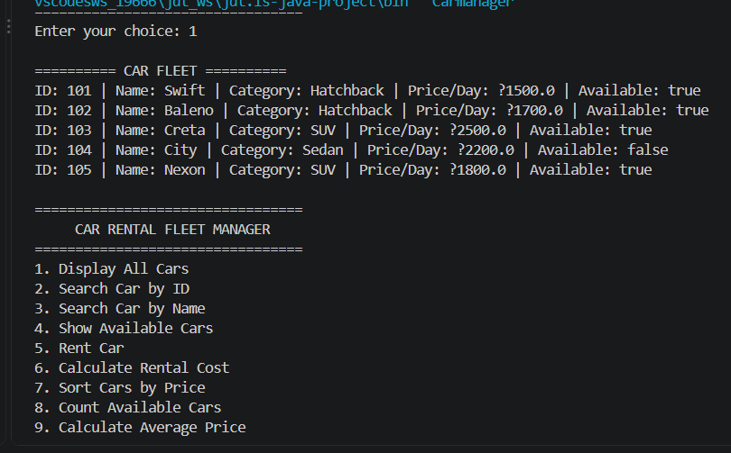
Rental Process Workflow
- Select Car - Display available cars (Module 1, 2)
- Check Availability - Verify car status (Module 2, 4)
- Customer Details - Input and validate (Module 1, 4)
- Rental Duration - Enter days (Module 1)
- Calculate Cost - Apply formula (Module 3, 5)
Fleet Statistics Output
--- Fleet Statistics ---
Total Cars : 5
Available : 4
Currently Rented: 1
Total Revenue : ₹7500 ========================
SLIDE 9: OUTPUT SCREENSHOT 2
OUTPUT SCREENSHOT 2
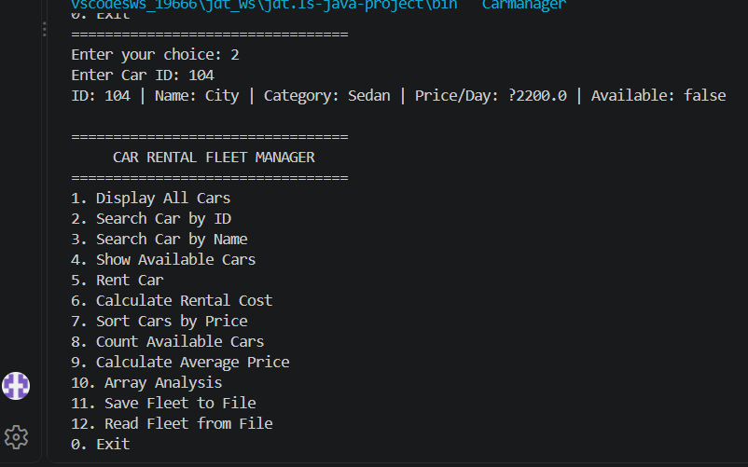
SLIDE 10: SAMPLE FLEET DATA
Sample Fleet Data
101 Swift Hatchback ₹1500.0 ✅ 102 Baleno Hatchback ₹1700.0 ✅ 103 Creta SUV ₹2500.0 ✅ 104 City Sedan ₹2200.0 ❌ 105 Nexon SUV ₹1800.0 ✅
Fleet managed using ArrayList and HashMap (Module 6) — sorted by price via Comparator (Module 5) and filtered using Streams (Module 6).
SLIDE 11: CONCLUSION & FUTURE WORK
Conclusion & Future Work
Conclusion
- Successfully demonstrates all six Java PSP modules in one cohesive project
- Progresses from basic I/O and control flow to advanced OOP and functional programming
- Integrates file handling, collections, and stream processing practically
- This project deepened my understanding of Java fundamentals and OOP principles while helping me grow more confident in building structured, maintainable applications
- It also strengthened my problem-solving and system design skills, improved my code organization and best practices, and gave me hands-on experience connecting multiple concepts into one cohesive solution
Future Work
GUI (Swing/JavaFX)
Transform the console-based application into an intuitive, modern GUI using Swing or JavaFX, enabling seamless user interaction, streamlined workflows, and a more polished professional experience.
Database Integration
Migrate from file-based storage to a robust relational database such as MySQL or PostgreSQL, ensuring reliable data persistence, concurrent access, and enterprise-grade scalability.
Web & REST APIs
Develop a full-featured web application with RESTful APIs to support cloud-based access, real-time synchronization, and seamless integration with third-party services and platforms.
Mobile Application
Create native Android and iOS applications to extend the platform's reach, empowering customers to book, track, and manage rentals on the go with push notifications and mobile-first convenience.
Advanced Features & Analytics
Implement payment gateway integration, customer review systems, loyalty programs, and an AI-driven analytics dashboard to support smarter, data-informed decision making.
Cloud Deployment & DevOps
Deploy on AWS or Azure with Docker containerization, CI/CD pipelines, real-time tracking, and automated scaling to deliver global accessibility, resilience, and high availability.
SLIDE 12: THANK YOU
Thank You
This Car Rental Fleet Manager project provided a comprehensive hands-on experience in applying core Java principles to a practical, real-world scenario. It effectively demonstrated object-oriented programming, data structures (like ArrayList and HashMap), file handling, and fundamental algorithms, all integrated into a functional application. We hope this presentation showcased the foundational knowledge and problem-solving skills acquired through this project.
"Programming is not about writing code - it's about solving problems systematically."
View Project on GitHub: https://github.com/gundumeghana/CarRentalFleetManager
Presented by: Gundu Meghana
KEY LEARNING OUTCOMES
This project successfully integrated all six Java PSP modules:
- Module 1 - Variables, Scanner, console I/O, arithmetic operations
- Module 2 - if-else, switch statements, do-while loops, menu system
- Module 3 - Methods, arrays, searching, sorting algorithms
- Module 4 - Classes, objects, constructors, encapsulation, exception handling
- Module 5 - String operations, file I/O (BufferedReader/Writer), Comparable/Comparator
- Module 6 - ArrayList, HashMap, streams, lambda expressions, Collectors

